**Sunday Matins**

***Abridged for Parish Use***

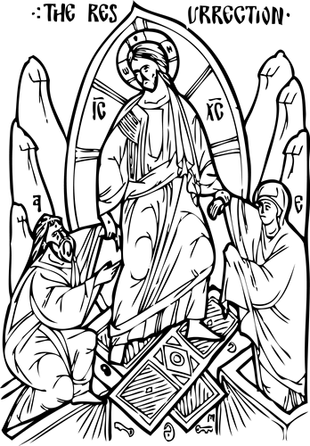

***Updated 8 July 2023***

**Usual Beginning**

| ***Priest:***  *Deacon:* Master, give the blessing.  *Priest:* + Blessed be our God, always, now and for ever and ever.   | *People:* Amín’. | Amen. | | --- | --- | | ***With no priest:***  *Deacon or Reader:* + Through the prayers of our holy fathers, Lord Jesus Christ, our God, have mercy on us.   | *People:* Amín’. | Amen. | | --- | --- | |
| --- | --- | --- | --- | --- | --- |

*R. Amin’.*

*Dcn/Rdr:* Glory be to You, our God, * **glo**ry be to You.

*People:* Heavenly King, Advocate, Spirit of Truth, * Who are everywhere present and fill all things, * Treasury of Blessings, Bestower of Life, * come, and dwell within us; * cleanse us of all that defiles us, * and, O *Good One,* **save** our souls.[1]

| *Dcn/Rdr:* + Sviatýi Bózhe, sviatýi krípkyi, sviatýi bezsmért*nyi, po***mý**lui nas.  *People:* + Sviatýi Bózhe, sviatýi krípkyi, sviatýi bezsmért*nyi, po***mý**lui nas.  *Dcn/Rdr:* + Sviatýi Bózhe, sviatýi krípkyi, sviatýi bezsmért*nyi, po***mý**lui nas.  *People:* + Sláva Otsíu, i Sýnu, i Svia*tómu* **Dú**khovi:  *Dcn/Rdr:* i nýni i povsiakchás, i na *víky* **vích**ni. Amín’. | *Dcn/Rdr:* + Holy God, Holy and Mighty, Holy and Immor*tal, have* **mer**cy on us.  *People:* + Holy God, Holy and Mighty, Holy and Immor*tal, have* **mer**cy on us.  *Dcn/Rdr:* + Holy God, Holy and Mighty, Holy and Immor*tal, have* **mer**cy on us.  *People:* + Glory be to the Father, and to the Son, and to the *Holy* **Spi**rit:  *Dcn/Rdr:* now and for e*ver and* **e**ver. Amen. |
| --- | --- |

*People:* Trinity most holy, have mercy on us. * Cleanse us of our sins, O Lord; * pardon our transgressions, O Master; * look upon our weaknesses and heal them, O Holy One; * *for the* **sake** of Your name.

| *Dcn/Rdr:* Hóspody, pomýlui. Hóspody, pomýlui. Hóspo*dy, po***mý**lui.  *People:* + Sláva Otsíu, i Sýnu, i Svia*tómu* **Dú**khovi:  *Dcn/Rdr:* i nýni i povsiakchás, i na *víky* **vích**ni. Amín’. | *Dcn/Rdr:* Lord, have mercy. Lord, have mercy. *Lord, have* **mer**cy.  *People:* + Glory be to the Father and to the Son and to the *Holy* **Spi**rit:  *Dcn/Rdr:* now and for e*ver and* **e**ver. Amen. |
| --- | --- |

*People:* Our Father, * Who art in heaven, * hallowed be Thy Name. * Thy Kingdom come. Thy will be done * on earth as it is in heaven. * Give us this day our daily bread; * and forgive us our trespasses * as we forgive those who trespass against us. * And lead us not into temptation, * but deliver *us from* **e**vil.

| ***With priest:***  *Priest:* For the kingdom, the power, and the glory are Yours, + Father, Son, and Holy Spirit, now and for ever and ever.   | *People:* Amín’.  *Dcn/Pr:* Hóspody, pomýlui. *(6)*  *People:* Hóspody, pomýlui. *(6)*  *Dcn/Pr:* + Sláva Otsíu, i Sýnu, i Svia*tómu* **Dú**khovi:  *People:* i nýni i povsiakchás, i na *víky* **vích**ni. Amín’. | Amen.  *Dcn/Pr:* Lord, have mercy. *(6)*  *People:* Lord, have mercy. *(6)*  *Dcn/Pr:* + Glory be to the Father, and to the Son, and to the *Holy* **Spi**rit:  *People:* now and for e*ver and* **e**ver. Amen. | | --- | --- | | ***With no priest:***  *Dcn/Rdr:* + Through the prayers of our holy Fathers, Lord Jesus Christ, Our God, Have mercy on us.   | *People:* Amín’.  *Dcn/Rdr:* Hóspody, pomýlui. *(6)*  *People:* Hóspody, pomýlui. *(6)*  *Dcn/Rdr:* + Sláva Otsíu, i Sýnu, i Svia*tómu* **Dú**khovi:  *People:* i nýni i povsiakchás, i na *víky* **vích**ni. Amín’. | Amen.  *Dcn/Rdr:* Lord, have mercy. *(6)*  *People:* Lord, have mercy. *(6)*  *Dcn/Rdr:* + Glory be to the Father, and to the Son, and to the *Holy* **Spi**rit:  *People:* now and for e*ver and* **e**ver. Amen. | | --- | --- | |
| --- | --- | --- | --- | --- | --- |

*Dcn/Rdr:* + Come, let us bow in worship be*fore the* **King,** our God.

*People:* + Come, let us bow in worship before *Christ, the* **King,** our God.

*Dcn/Rdr:* + Come, let us bow in worship and fall down before the very Lord, Jesus *Christ, our* **King** and God.

**Psalm 50**

Have mercy on me, O God, in the greatness of Your compassion; * according to the multitude of Your mercies *blot out* **my** offense.

Wash me thoroughly from my iniquity, * and *cleanse me* **from** my sin.

*1* For I acknowledge my iniquity, * and my sin is al*ways be***fore** me.

*2* Against You alone have I sinned * and done what is *evil* **in** Your sight,

*1* That You may be justified when You speak * and *win when* **You** are judged.

*2* Behold, in wickedness I was conceived * and in sin my *mother* **bore** me.

*1* For see, You have loved truth; * You have shown me the hidden and secret things *of your* **wis**dom.

*2* Sprinkle me with hyssop and I shall be clean. * Wash me and I *shall be* **whi**ter than snow.

*1* Make me hear joy and gladness; * the bones *that* *were* **crushed** shall rejoice.

*2* Turn away Your face from my sins, * and blot out all *my i***ni**quities.

*1* Create in me a pure heart, O God, * and renew a right spi*rit with***in** me.

*2* Cast me not from Your presence, * nor deprive me of Your *Holy* **Spi**rit.

*1* Give me again the joy of Your salvation, * and sustain me with Your *sovereign* **Spi**rit.

*2* I will teach transgressors Your ways, * and sinners *will re***turn** to You.

*1* Deliver me from blood guilt, O God, the God of my salvation, * and my tongue shall ring *out Your* **jus**tice.

*2* Lord, You will open my lips, * and my mouth *shall de***clare** Your praise.

*1* For if You had wanted sacrifice, I would have given it; * You will not take pleasure *in burnt* **of**ferings.

*2* A sacrifice to God is a contrite spirit. * A humbled and con*trite heart* **God** will not spurn.

*1* Deal favorably, O Lord, with Sion in Your good pleasure * and let the walls of Jeru*salem* **be** rebuilt.

*2* Then You will be well-pleased with a sacrifice of justice, oblations and holocausts; * then they will lay calves u*pon Your* **al**tar.

**God the Lord**

***All*:** *(Tone 4, Prokeimenon)*

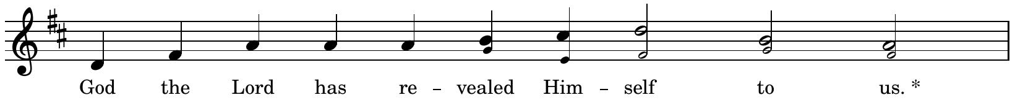

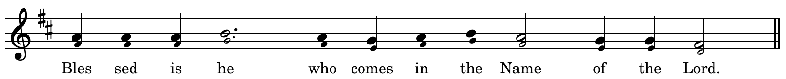

*Dcn/Rdr:* Give thanks to the Lord, for He is good; * for His love endures forever.

***All*: God the Lord…**

*Dcn/Rdr*: They encircled me, compassed me about; * in the Lord’s name I crushed them.

***All*: God the Lord…**

*Dcn/Rdr*: I shall not die, I shall live * and recount the deeds of the Lord.

***All*: God the Lord…**

*Dcn/Rdr*: The stone which the builders rejected has become the cornerstone. * This is the work of the Lord, a marvel in our eyes.

***All*: God the Lord…**

**Resurrectional Troparion**

***The Resurrectional Troparion of the Sunday is sung.***

**Hosts of Angels**

***All:***

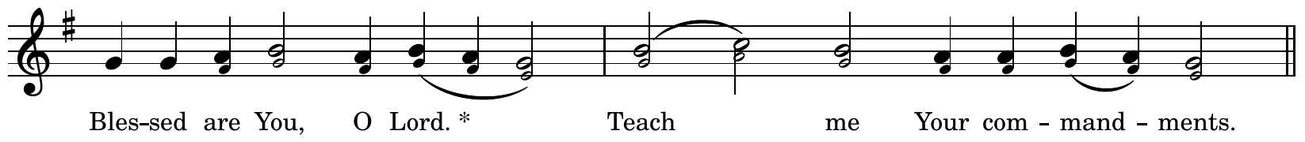

*Choir:* The hosts of angels were a*mazed and* **daz**zled * when they beheld You, O Savior, a**mong** the dead, * destroying the po*wer* of **Death,** * raising up Adam with **You** ** and re**lea**sing * all the souls from **Ha**des.

***All:* Blessed are You, O Lord, * teach me Your commandments.**

*Choir:* The radiant angel standing *by the* **grave** * cried out to the ointment-bearing **wo**men: * Why do you lament and mingle your tears *with the* **spi**ces? * Look upon the grave and re**joice,** ** for the **Sa**vior * is risen from the **dead.**

***All:* Blessed are You, O Lord, * teach me Your commandments.**

*Choir:* The ointment-*bearing* **wo**men * hastened very early to Your **grave.** * But the angel stood by *them and* **said:** * The time for lamenting is **no** more. ** Do not **cry,** * but go and announce the Resurrection to the dis**ci**ples.

***All:* Blessed are You, O Lord, * teach me Your commandments.**

*Choir:* O Savior, the ointment-*bearing* **wo**men * came to Your grave with **oint**ments, * and they heard the angel *say to* **them:** * Why are you seeking the Living One a**mong** the dead? ** Indeed, He is **God.** * He is risen from the **dead.**

***All:***

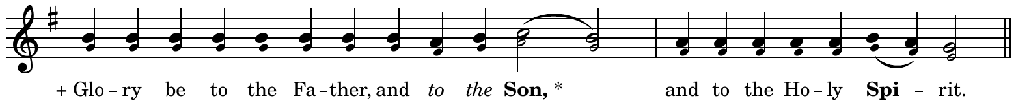

*Choir:* We wor*ship the* + **Fa**ther * and His Son and His Holy **Spi**rit, * the Holy Trinity, *One in* **es**sence, * and we cry out with the **se**raphim: ** Holy, **ho**ly, * holy are You, O **Lord.**

***All:***



*Choir:* O Virgin, you bore the Gi*ver of* **Life.** * Who redeemed Adam from his **sin** * and granted *joy to* **Eve** * instead of **sad**ness. * For He Who is both *God and* **Man** * was incarnate of **you,** ** and He has re**stored** life * to those who had strayed a**way** from it.

***All:***

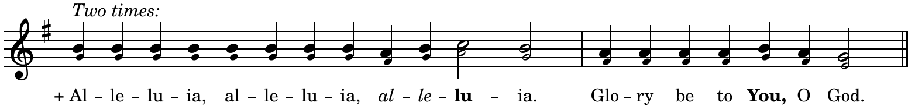

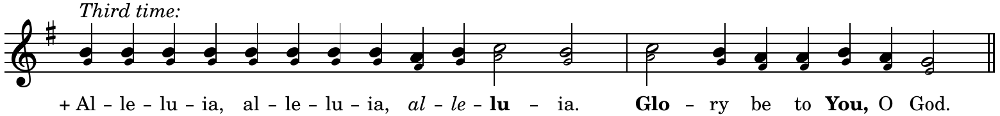

**Prokeimenon**

| ***With priest:***  *Deacon:* Wisdom!  *Priest:* Peace be with all.  *Deacon:* Wisdom! Let us be attentive! | ***With no priest:***  *Dcn/Rdr:* + Through the prayers of our holy fathers, Lord Jesus Christ, our God, have mercy on us.   | *People:* Amín’. | Amen. | | --- | --- | |
| --- | --- | --- | --- |

***The prokeimenon of the Sunday is sung.***

*[Deacon or Priest:* Let us pray to the Lord!

| *People:* Hóspody, pomýlui. | Lord, have mercy. *]* |
| --- | --- |

| ***With priest:***  *Priest:* For You, our God, are holy, and we give glory to You, + Father, Son, and Holy Spirit, now and for ever and ever.   | *People:* Amín’. | Amen. | | --- | --- | | ***With no priest:***  *Dcn/Rdr:* + Through the prayers of our holy fathers, Lord Jesus Christ, our God, have mercy on us.   | *People:* Amín’. | Amen. | | --- | --- | |
| --- | --- | --- | --- | --- | --- |

**Prayers before the Gospel**

***All:*** *(Tone 4, Prokeimenon)*

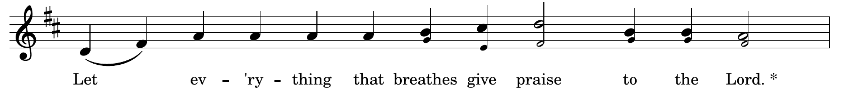



*Dcn/Rdr:* Praise God in His holy place, * praise Him in His mighty heavens.

***All:*** **Let everything that breathes…**

*[Deacon:* That we may be deemed worthy of hearing the holy Gospel, let us pray to the Lord, our God.

| *People:* Hóspody, pomýlui. *(3)* | Lord, have mercy. *(3) ]* |
| --- | --- |

**The Reading of the Matins Gospel**

| ***With priest:***  *Priest:* Wisdom!  Stand aright!  Let us listen to the holy Gospel.  Peace + be with all.  *People:*   | I dúkhovi tvoyému. | And with your spirit. | | --- | --- |   *Deacon:* A reading from the holy Gospel according to *(name)*.  *People:*   | + Sláva Tobí, Hóspody, sláva Tobí. | + Glory be to You, O Lord, glory be to You. | | --- | --- |   *Priest:* Let us be attentive!  ***Priest reads the appointed Resurrection Gospel.***  *People:*   | + Sláva Tobí, Hóspody, sláva Tobí. | + Glory be to You, O Lord, glory be to You. | | --- | --- | | ***With no priest:***  *Deacon:* A reading from the holy Gospel according to *(name)*.  *People:*   | + Sláva Tobí, Hóspody, sláva Tobí. | + Glory be to You, O Lord, glory be to You. | | --- | --- |   ***Deacon reads the appointed Resurrection Gospel.***  *People:*   | + Sláva Tobí, Hóspody, sláva Tobí. | + Glory be to You, O Lord, glory be to You. | | --- | --- | | ***With no priest or deacon:***  *(The Gospel is NOT CHANTED, but read in a normal voice facing East.)*  *Reader:* A reading from the Holy Gospel according to *(name)*.  ***Reader reads the appointed Resurrection Gospel in a normal voice.*** |
| --- | --- | --- | --- | --- | --- | --- | --- | --- | --- | --- | --- | --- |

**Hymn of the Resurrection**

*(Tone 6, samohlasen)*

***All:*** *Having be***held** the Resurrection of **Christ,** * let us + adore the holy Lord Jesus, Who a*lone is* **sin**less. * We + bow to your cross, *O* **Christ,** * and we praise and glorify Your holy Resur**rec**tion. * You are our God and besides You we recog*nize no* **o**ther, * and we invoke *Your* **name.** * Come, all you faithful, and let us + bow to the holy Resurrection of **Christ,** * since through the Cross joy has come to *all the* **world.** * Ever praising *the* **Lord,** * let us extol His Resur**rec**tion, * since He, having endured the *Cruci***fi**xion, * *has* **des**troyed death by His **death.**

**The Praises**

*(Tone 6, samohlasen)*

*Let* **e**verything that lives and that **breathes** * give praise *to the* **Lord.** * Praise the Lord from *the* **hea**vens; * praise Him in the **heights.** * *To* **You** is due a **hymn,** O God.

*Praise* **Him,** all His **an**gels. * Praise Him, *all His* **hosts.** * *To* **You** is due a **hymn,** O God.

**Great Doxology**

*[Deacon or Priest:* Glory to You Who have shown us the light!*]*

***All:***

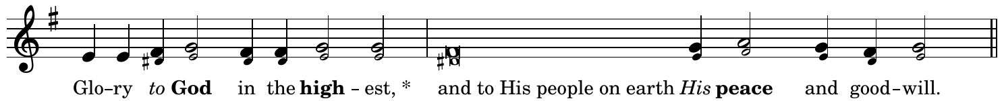

Lord God, Heaven*ly* **King,** Almighty God and **Fa**ther, * with the Lord Jesus Christ, only Son of the Father, and the Ho*ly* **Spi**rit.

We praise You, *we* **bless** You, we worship **You,** * we glorify You, we thank You for Your *great* **glo**ry.

Lord God, Lamb *of* **God,** Son of the **Fa**ther, * You take away the sin of the world, *have* **mer**cy on us.

You take *a***way** the sins of the **world,** * **hear** our prayer.

You *are* **sea**ted at the right hand of the **Fa**ther, * *have* **mer**cy on us.

For You alone *are* **ho**ly, You alone are the Lord, Jesus **Christ,** * for the glory of God *the* **Fa**ther. Amen.

I *will* **bless** You day after **day,** * and praise Your name *for***e**ver.

Count *us* **wor**thy, O **Lord** * of passing *this* **day** without sin.

Blessed *are* **You,** O Lord, God of our **fa**thers, * and praised and glorified is Your name *for***e**ver. Amen.

Let *your* **mer**cy, O Lord, be u**pon** us * because we have set *our* **hope** in you.

+ Blessed *are* **You,** O **Lord,** * teach me Your *com***mand**ments.

+ Blessed *are* **You,** O **Mas**ter, * make me understand Your *com***mand**ments.

+ Blessed *are* **You,** O Holy **One,** * enlighten me with Your *com***mand**ments.

O Lord, You *have* **been** our **re**fuge * from one generation to *the* **next.**

I *said:* **Lord,** have mercy on **me,** * heal my soul, for I have sinned *a***gainst** You.

O Lord, I have fled *to* **You,** teach me to do Your **will,** * for You, O Lord, are *my* **God.**

In You is *the* **source** of **life** * and in *Your* **light** we see **light.**

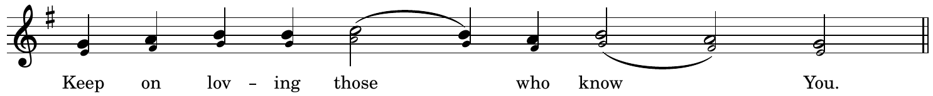

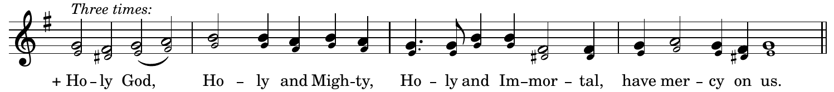

+ Glory be to Father, and to the Son, and to the Holy **Spi**rit, * now and for ever *and* **e**ver. Amen.

Holy and Immortal, have mercy on us.

+ Holy God, Holy and Mighty, Holy and Immortal, have mercy on us.

**Troparion After the Great Doxology**

***When the Tone of the Week is 1, 3, 5, or 7:***

*(Tone 2, Troparion)*

**

*Let us* **sing** to **Him** Who is *risen* **from** the tomb, * *the* **Au**thor of **Life** Who *has crushed* **Death** by His death * *and be***stowed** on us **vic**tory *and great* **mer**cy.

***When the Tone of the Week is 2, 4, 6, or 8:***

*(Tone 2, Troparion)*

**

*You* **broke** the curse of Death and thus de**li**vered us from the snares *of the* **E**vil One. * *Then* *You ap***peared** to Your A**pos**tles and *sent them* **forth** to preach, * *and* **through** them You have be**stowed** Your *peace u***pon** all the world, * *for* **You** a**lone** are *rich in* **mer**cy.

**Thus ends Matins.**

**We now proceed to sing the Opening Hymn for the Divine Liturgy.**

Updated 8 July 2023

Compiled, Arranged, Notated, and Typeset by Rdr. Alex Harter

alexharter97@gmail.com

Sources:

Icon of the Resurrection by Fr. John Matusiak

*Resurrectional Moleben* - Ukrainian Catholic Eparchy of St. Nicholas

*Divine Liturgy of St. John Chrysostom* - Ukrainian Greek Catholic Church (1988)

*Divine Liturgy: An Anthology for Worship* -Metropolitan Sheptytsky Institute

*Divine Office: Horologion, Octoechos, Triodion, Menaion* - Ukrainian Catholic Eparchy of Stamford

*The Order of Matins on Sundays - Volume One: Sundays after Pentecost* - Metropolitan Cantor Institute

*Napivnyk Tserkovnyi* (Rome, 1959)

1. During Paschal Time, *Glory be to You, O God* and *Heavenly King* are replaced by *Christ is Risen*, which is sung thrice. Between Ascension and Pentecost, they are omitted.